**.Isnumeric():**

It returns true if given input is numeric else false

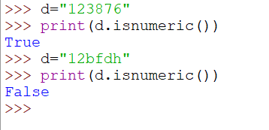

**.isalpha()**

It returns true if given input is alphabets else false

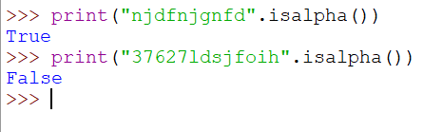

**.isdigit()**

It returns true if given input is numeric else false

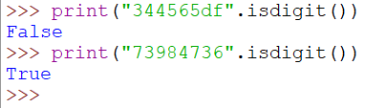

**Upper**

It coverts to upper letters



Lower

It coverts to lower cases



**Isalpha()**

It returns true if given data is alphabets

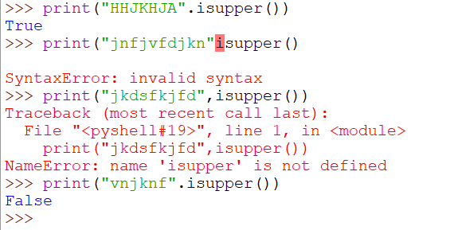

**Islower()**

It returns true if given data is lower cases

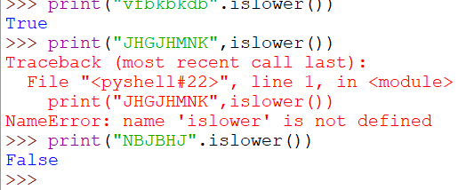

\\

Conditional statements:

1)if

2)else

3)elif

